**Introduction**

**Name Of Business:** GLOWING LEGACY YOUTH CENTER

**Nature Of Business:** Youth recreation center also offers childcare and an after-school program.

**Name Of Principles:** Jordan Bullock, Rogelio Castro, Ashley Williams, Lauren Hilton, and Leroy Bracey

**Executive Summary:**

Our new youth recreation center seeks to transform youth development by combining leisure, childcare, and after-school programs. Our goal is to celebrate and develop each child's potential. Come along on this journey with us as we mold the leaders of tomorrow, one happy moment and educational encounter at a time.

**Statement of Financing need:**

To Whom it may concern,

We are writing to express our sincere need to find funding for the Youth Recreation Center we are opening. This center will be a staple in the community, allowing busy parents somewhere safe to bring their children and offering various after-school programs and childcare options. This establishment will provide programs that will foster our youth’s minds and nurture our children, allowing them to flourish in a safe environment where they will not be judged. We will offer educational programs and fun where they can be kids.

However, we encountered financial constraints while finding adequate funding for the recreational center. Our utmost priority is to provide the youth in this community with a safe place that allows them to grow. Our team is requesting financial assistance to back this program, and your support would help alleviate the financial burden. We seek $500,000 and will utilize these funds to ensure Glowing Legacy can succeed.

Thank you for considering our request for funding, and we appreciate your willingness to aid that will allow us to create this valuable establishment within the community.

**Industry Analysis and Description of Venture**

**Future Outlook and Trends:**

Just as in most industries with both products and services, there is a steady increase in cost. Most childcare and youth recreation businesses can be expensive. Depending on the area and the median income, it is still not feasible for some families. Financial assistance is a crucial asset to any business and is now necessary for many families. Thankfully, we offer assistance to families that meet our requirements. Another issue that we may face is hiring dependable staff. Staffing issues have been widespread, especially since the COVID-19 outbreak. Hiring staff that have flexible hours is necessary in this industry.

**SWOT Analysis:**

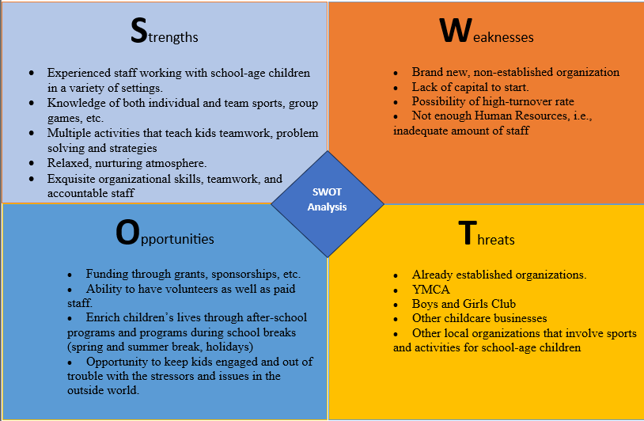

**Analysis of Competitors:**

|  |  |  |  |
| --- | --- | --- | --- |
| FACTOR | GLOWING LEGACY | YMCA | BOYS & GIRLS CLUB |
| PRICE | LOW | MODERATE | MODERATE |
| AMENITIES | 16 | 12 | 7 |
| AUDIENCE | KIDS, ADULTS | KIDS, ADULTS | KIDS |
| PLACE | ALL 50 STATES | ALL 50 STATES | ALL 50 STATES |

**Market Segmentation:**

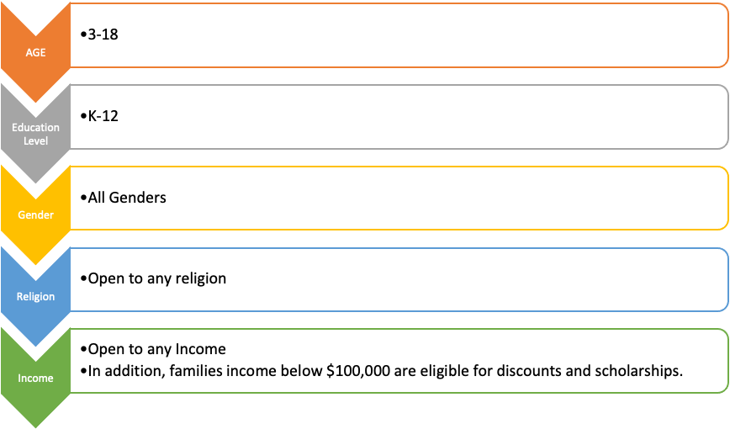

**Industry Forecast:**

Market analysis:

Centers for youth are experiencing exponential growth because of their services for children and young adults. I have thoroughly researched the direction that the child and youth services industry is going and found that the market is anticipated to expand from “$156.93 billion (about $480 per person in the US) in 2024 to an impressive 199.12 billion by 2028.” (Research and Markets, 2024) This is important because it demonstrates the need within the market with a 6.1% compound annual growth rate (CAGR). That shows significant growth in this industry and its profitability as a business venture. We must understand the market challenges to adjust our business plan to ensure the business will thrive and grow. One challenge encountered was adequate job training and employment opportunities. This can lead to inefficient help for children in transition or who need help because we may not have sufficient tools to help them. We can ensure that we properly establish a way to remedy this challenge to provide these children with the opportunities they need to flourish.

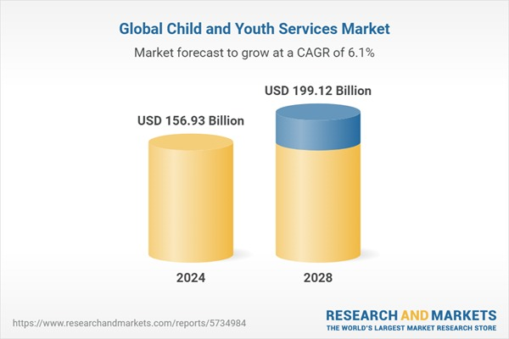

Growth opportunities:

The rapid growth in this industry can be attributed to the implementation of “resilience building, the implementation of trauma-informed care, holistic development programs, initiatives promoting diversity and inclusion, and the provision of preventive mental health services.” (*Child and youth services global market report 2024*) These factors will be considered when creating our business model to build a safe place for youth and provide them with the necessary resources. We can utilize predictive analytics to identify and understand those using the center most frequently and to aid the children and families within the community that would benefit most.

**Description of Venture**

**Product/Service:**

Our youth center will offer diverse services and activities for children, including recreational sports, art, music, and development programs to enhance their education. These diverse services will allow the children in our community to experience different activities and discover their interests. In addition to our existing programs, we will also have counselors that the children and young adults can visit for advice and guidance. We want to ensure the children within our community have access to the support they need to feel safe and comfortable. Glowing Legacy Youth Center’s goal is to provide children with the tools they need to be successful, flourish, and grow. We want this to be a place where they can connect with peers and have the hands-on experience they may not get from traditional after-school programs.

**Vision:**

Our vision is to create a balance in life for family, friends, and parents. We provide assistance through childcare and after-school programs to support working individuals. This creates a safe and caring place where a kid can be a kid, and parents can have peace of mind while away**.**

**Mission Statement:**

At Glowing Legacy Youth Center, we pride ourselves on four values: Love, Integrity, Family, and Encouragement (L.I.F.E). With these principles, we can ensure that we will act with class, respect others, maintain integrity, and always provide an inclusive atmosphere that allows each kid equal opportunity. We take pride in servicing “OUR” future leaders of tomorrow.

**Equipment and Personnel needs:**

|  |  |  |
| --- | --- | --- |
| **Personnel** | **Salaries** | **# of Personnel** |
| Director | $45,000.00 | 1 |
| Youth Counselors | $25,000.00 | 8 |
| Counselor Aids | $18,000.00 | 4 |
| **Total** | $317,000.00 | 13 |

|  |  |  |
| --- | --- | --- |
| **Equipment** | **Cost** | **# of Items** |
| Basketball Goals | $350.00 | 4 |
| Basketballs | $25.00 | 10 |
| Jungle Gym | $450.00 | 1 |
| Jump Ropes | $10.00 | 15 |
| dodge balls | $7.00 | 20 |
| Kids' Books | $7.00 | 25 |
| Hula-hoops | $10.00 | 6 |
| benches | $150.00 | 8 |
| Chairs | $30.00 | 25 |
| Tables | $100.00 | 5 |
| Water Dispensers | $300.00 | 4 |
| **Total** | $6,275.00 | 123 |

**Marketing Plan**

**Pricing:**

An effective pricing model is essential to the marketing strategy for Glowing Legacy Youth Center. In this process, multiple elements must be considered to appropriately identify specific prices that become accessible for our customers while at the same time remaining competitive in the market and delivering enough profit. Businesses in this industry offer a broad range of services that can be accessed mainly through a membership pricing model. Glowing Legacy Youth Center has implemented a membership pricing model through a competitive pricing strategy that analyzes essential organizations that make up this industry, such as the YMCA and Boys & Girls Club.

Pricing, included in the 4 Ps of marketing, is an integral part of any marketing plan as it can influence the overall success of a business by optimizing its sales, reaching target markets and customers, and using it as a competitive advantage through an effective competitive pricing strategy. The following charts compare the prices of two of the main services offered in our youth center, which are our membership options and childcare services, compared to the two organizations previously mentioned utilizing the analysis of competitors section previously developed on our business plan.

|  |  |  |  |  |
| --- | --- | --- | --- | --- |
| Competitive Pricing Strategy | | | | |
| Membership Monthly Prices | | | | |
|  | **GL** | **YMCA** | **B&G Club** |  |
| Adult | $ 55.00 | $ 62.00 | - |  |
| Household | $ 65.00 | $ 74.00 | - |  |
| Kid | $ 20.00 | $ 26.00 | $ 50.00 |  |
|  | | | | |
|  | | | | |
| Childcare Services (5 days a week) | | | | |
|  | **GL** | **YMCA** | **B&G Club** |  |
| Monthly Fees | $ 500.00 | $ 650.00 | - |  |
| Weekly Fees | $ 140.00 | - | $ 185.00 |  |

***Memberships.***

Customers who buy our membership plans gain unlimited access to our center and all its services and amenities. Children can be part of a broad range of activities, from recreational sports to art and music to development programs to enhance their education. Glowing Legacy Youth Center’s goal is to provide children with the tools they need to be successful, flourish, and grow. We want this to be a place where they can connect with peers and have the hands-on experience they may not get from traditional after-school programs.

***Childcare Services.***

At Glowing Legacy, we understand the importance of high-quality childcare services and how they can positively impact the lives of children, their parents, and the community. We offer a Childcare service that prioritizes the safety and health of children and contributes to their social, emotional, and communicational development. Prices mentioned in the chart are based on customers who are not members of our center. Members have access to a considerable discount on these services.

**Distribution:**

We intend to sell our services through in-person distribution through our various activities for the children attending our youth center. The students, both children and young adults attending our existing programs, will be aware of new and upcoming activities and events held at Glowing Legacy Youth Center. They can help us grow our community by spreading the word to other families and friends.

**Promotion:**

Glowing Legacy Youth Center will be using numerous channels to promote its business. The use of social media will be crucial to sending vital information quickly and straightforwardly. There will be a business page on Facebook that will keep the families of the students that attend up to date with all the events, business hours, etc. Social media will also show potential customers the dynamic of our growing business. We will also send flyers to all the local schools to be passed out to every kid, advertising our programs. Smaller signs will also be outside our center advertising programs and upcoming events near all local schools.

**Organizational Plan**

**Form of Ownership:**

Glowing Legacy will be an LLC.

**Management Team:**

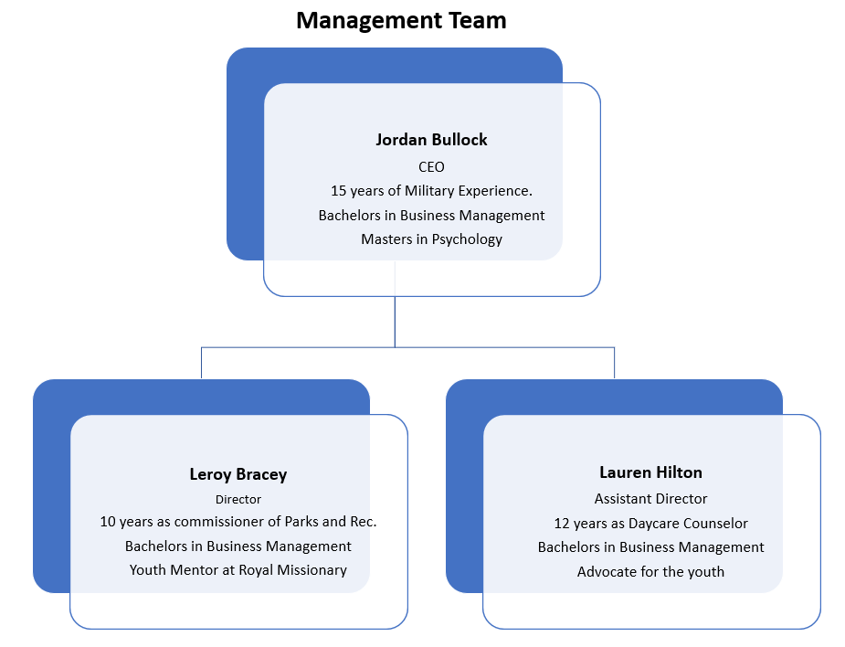

**Roles and Responsibilities:**

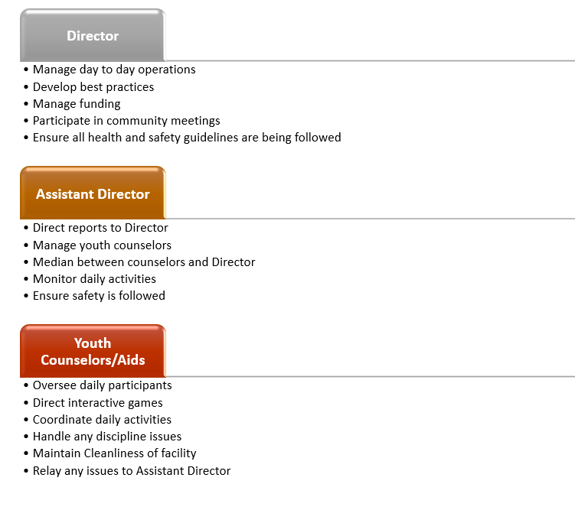

**Physical facility:**

* Glowing has state-of-the-art gyms, pools, centers for childcare and teens, and plenty of outdoor space(s).
* The first location will open in Tampa, FL, about 15 minutes from Tampa Airport. This will allow residents and tourists to stay busy during the Summer of 2024.
* With its convenient location, Glowing can be a valuable resource for anyone to use!

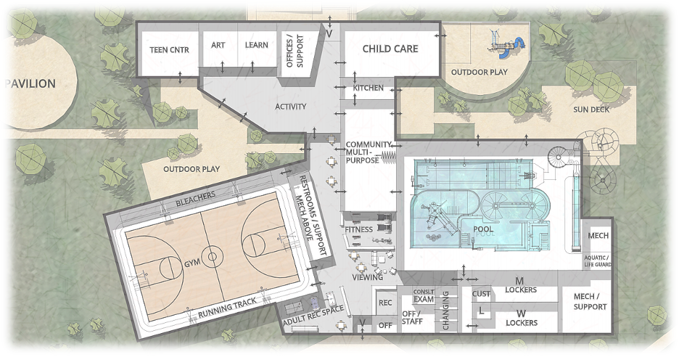

**Supply chain and inventory management:**

* We obtain our gym equipment from manufacturers and merchants across the globe, specifically from Europe.
* Although the equipment sometimes faces tight deadlines and logistical hurdles, we prioritize ensuring that necessary, non-damaged shipments arrive concurrently at various locations.
* Have you ever utilized old equipment as a kid, teenager, or adult, even though you are paying for a membership? Our clients will have nothing but the most up-to-date gym equipment, along with our exceeding-standards facilities.
* We have utilized the five phases of inventory within inventory management, purchasing, production, stock holding, sales, and reporting.



**Pro Forma Balance Sheet**

|  |  |
| --- | --- |
| PRO FORMA BALANCE SHEET | |
| GLOWING LEGACY YOUTH CENTER | |
| For 2025 |  |
|  | **2025** |
| **Assets** |  |
| *Current Assets* |  |
| Cash and equivalents | $100,000 |
| Accounts Receivable | $500,000 |
| Inventory | $20,000 |
|  |  |
| *Fixed Assets* |  |
| Land | $1,500,000 |
| Buildings | $700,000 |
| **Total Assets** | **$2,820,000** |
|  |  |
| **Liabilities** |  |
| *Current liabilities* |  |
| Accounts Payable | $26,416 |
|  |  |
| *Long term liabilities* |  |
| Long term debt | $300,000 |
| **Total Liabilities** | **$326,416** |
|  |  |
| **Owners Equity** |  |
| Capital Account | $20,000 |
| Retained Earnings | $50,000 |
| **Total liabilities & equity** | **$70,000** |

**Pro Forma Income Statement:**

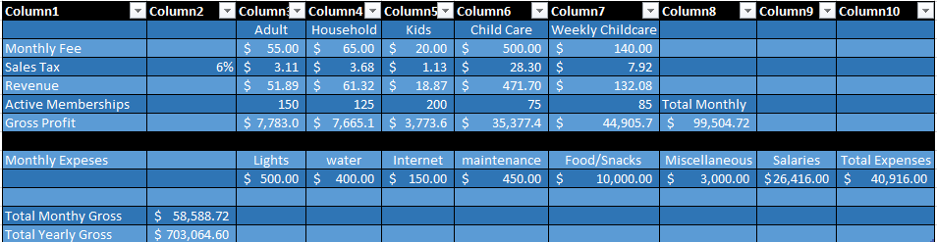

**CAPITAL SOURCES & USES TABLE**

|  |  |
| --- | --- |
| Purchase Price $500,000 |  |
| Sources | **Uses** |
| Equity Financing: | Youth Center Property $500,000 |
| Founders’ Investment $250,000 | Equipment & supplies $15,000 |
| Additional Investors $150,000 | Renovation costs $30,000 |
| Total Equity $400,000 | Promotional expenses $5,000 |
| Debt Financing: | Initial operating expenses $50,000 |
| Bank Loan $200,000 |  |
| Total sources of capital $600,000 | **Total uses of capital: $600,000** |

**References**

Research and Markets. (2024, March 12). *Child and youth services market forecast:* *Strong growth and technological innovations to propel global industry to* *$199.12 billion by 2028*. GlobeNewswire News Room. https://www.globenewswire.com/en/news-release/2024/03/12/2844938/28124/en/Child-and-Youth-Services-Market-Forecast-Strong-Growth-and-Technological-Innovations-to-Propel-Global-Industry-to-199-12-Billion-by-2028.html

Research and Markets. (n.d.). *Child and youth services global market report 2024*. Research and Markets - Market Research Reports - Welcome. https://www.researchandmarkets.com/report/youth-service?utm_source=BW&utm_medium=PressRelease&utm_code=8fv5wp&utm_campaign=1546631%2B-%2BWorldwide%2BChild%2Band%2BYouth%2BServices%2BIndustry%2Bto%2B2030%2B-%2BFeaturing%2BUnited%2BStates%2BChildren%27s%2BBureau%2C%2BThe%2BEuropean%2BChild%2BSafety%2BAlliance%2Band%2BVoices%2Bof%2BYouth%2BAmong%2BOthers&utm_exec=jamu273prd