*Marketing Plan*

*Lauren Hilton*

*Saint Leo University| MKT-301*

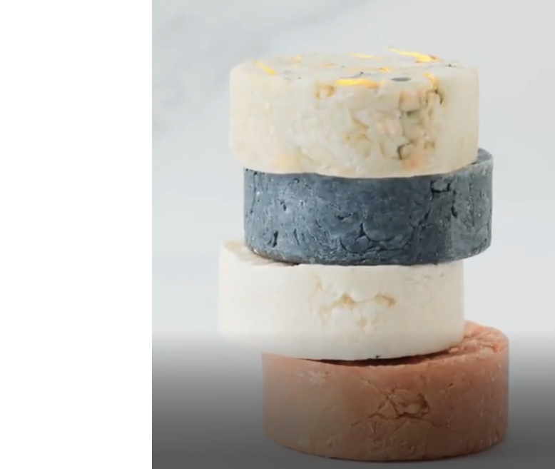

Table of Contents

Executive Summary 2

Problem 2

Product Design 2

Description Feature and Benefits Chart 3

Feature and Benefit Chart Objectives 4

Strengths, Weaknesses, Opportunities, Threats 5

Action Plan 5

Supply Chain Plan 6

Segmentation 8

Young Conservationists: 8

Working Professionals: 8

Summary of Segmentation Analysis 10

Integrated Marketing Communications 11

# Executive Summary

## Problem

There is high competition when a new business enters the online market. Specific steps must be taken to differentiate your product from other online products. Lavish Soap Company’s primary concern is harnessing qualities that benefit each individual and their unique preferences while being environmentally friendly. In such a competitive business market such as this one, a company must take the time to understand its vital clientele while leaving a great impression to create a solid relationship. Many elements must be tied together to ensure that this company will succeed and meet the customers' needs. All these are essential steps implemented within our company to ensure lasting success and deliver a product we know our customers will love.

## Product Design

Lavish Soap Co incorporates only the purest and all-natural ingredients, all of which come from the earth. We utilize these essential oils in our handmade soaps to target the many different skin types and promote healing from within. Do you have overly dry skin with rough patches? Maybe you have eczema or dermatitis. These products are meant to be soothing while also harnessing the healing punch of organic essential oils. Each eco-friendly soap uses all-natural and biodegradable products that are highly important to our consumers. If you purchase soaps from our online store, we know you are interested in saving our beautiful planet. This is the sole focus of our lavish soaps, and we have high hopes that we can reduce our carbon footprint.

We also have a line geared toward children. This line includes the same bountiful ingredients and promises to be tear-free. The kid’s line has unique design elements that make kids want to get clean. We offer soaps in various colorful shapes and sizes that attract children. It is essential to our company that we create a product that makes bath time a little more kid-friendly and parent-approved!

Lastly, if you have specific skincare needs, we offer a fully customizable experience that allows you to create a unique soap. We offer a questionnaire that helps us determine what properties are essential to you and then enables you to create a soap that conquers all these needs. This is exclusive to our company, and we hope it will aid us in creating a product that our customers will continue to enjoy and ensure they return to us.

# Description of Features and Benefits

These charts demonstrate the critical features and benefits of Lavish Soap Co. My startup company has a go-green initiative and places significant importance on leaving behind the smallest carbon footprint possible. Our products are made from the purest ingredients you can get directly from the earth. Our goal is to make a product that our consumers love and is also beneficial to their specific skincare needs. We pride ourselves on being a company that creates products that the entire family can enjoy.

## Feature and Benefit Chart Objectives

|  |  |
| --- | --- |
| Feature | Benefit |
| Eco-friendly Products | Helps in the effort to save the environment  Reduce carbon footprint |
| High quality ingredients | Longer lasting  Better for your body |
| Fully Customizable | Target specific skincare needs  Increasing customer loyalty |
| Kid-friendly products | No-more tears  Makes bath time easier |
| Unique Color and Design | More appealing to the eyes  Make great gifts |

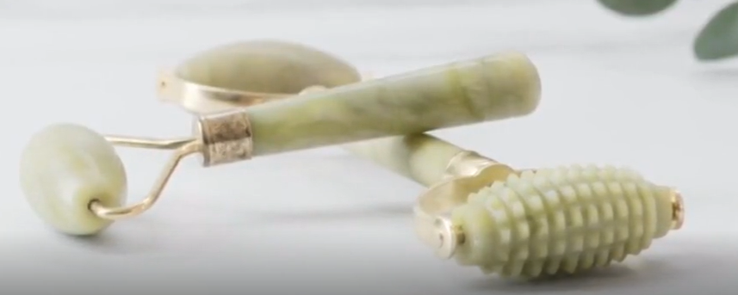

# Strengths, Weaknesses, Opportunities, Threats

|  |  |
| --- | --- |
| Strengths | Weaknesses |
| Online experience is fully customizable to meets client’s demands | No- Store front— could affect the clientele we have |
| Ability to use online resources and data to visualize which products are customer favorites | Limited customer interaction, because it is based solely online |
| Uses all eco-friendly essential oils/ingredients | Higher costs because of the quality of ingredients utilized |
| Kid-friendly line offered for families | High competition within the luxury bath market |
| Convenience—can order from your couch and have it delivered to your door | Ability to create a long-term customer |
| Opportunities | **Threats** |
| Ability to market/sell your product beyond where the company originates | Inability to receive product directly after purchase |
| Unlimited opportunities to make changes to website layout based on current sales trends | No “store front” to attract people in |
| Taking steps to ensure customer security | Fraud is more likely in an online business |
| More flexibility for meeting/matching prices, and making decisions regarding sales | Shipping fees can deter potential buyers |
| Utilization of social media to brand yourself | Other companies selling equally “green” products at a lower cost |

## Action Plan

A key strength within my online business is the ability to fully customize my product to meet every consumer’s demand based on their unique skincare result. I believe this will help yield a profit.

The greatest weakness of concern for my company would be the loss of face-to-face interaction that you would receive when purchasing within a store.

Our most crucial marketing opportunity is the ability to reach consumers outside of our network. This is beneficial because it creates more growth opportunities.

The most prominent threat is other companies selling “similar” products at a lower cost; this could deter buyers.

|  |  |  |
| --- | --- | --- |
| Supply Chain for Exotic Soaps | | |
| Upstream | **Mid-Stream** | **Downstream** |
| Goat feed | Raw milk | Eco-friendly packaging |
| Goats | Honey | Bubble wrap |
| Bees | Bottled essential oils | Distribution Center |
| Ingredients within Essential Oils | Supply truck | Handmade soap |

# Supply Chain Plan

Lavish Soap Co. uses all-natural ingredients derived directly from the Earth and locally sourced. Our company is proud to support local family businesses with values aligned with our cruelty-free products. A significant amount of work goes into creating a valuable product line for both the consumer and the company. Many of the ingredients we utilize within our handmade soaps come from local farms in Idaho, such as our family-owned and operated goat milk distributor, Goatilicious, LLC. Our pure raw honey comes from a small-town beekeeper in Fruitland, Idaho, and our coconut oil is shipped from Hummingbird Wholesale in Eugene, Oregon. Our signature ingredient is the essential oils we utilize in our organic soaps, which we purchase wholesale through Young Living, a well-respected company with which we are partnered. Each ingredient is vital to creating a recipe we know our consumers will love and want to continue participating in.

Our products are produced, packaged with recycled, biodegradable paper, and stored until purchased online and shipped directly to the consumer. Our local distribution center focuses on providing the best customer service through our online 24-hour chat service to answer questions and address any concerns.

The main concern Lavish Soap Co. could encounter is the fair treatment of the animals, helping to produce raw ingredients for our products. It is essential to our company that our products remain in their purest form and that the companies we work with maintain the same ethical standards throughout our partnership. Each of these factors aids in the successful development of our product from start to finish.

# Segmentation

## Young Conservationists:

This group comprises young males and females interested in products that benefit the planet and their bodies. I mention youth as a part of this group because millennials are often very focused on self-care and taking full advantage of the products they use. Although these eco-friendly soaps are on the higher end, they are willing to spend a bit extra money to maximize the benefits.

**Psychographics for Young Conservationists**

**Purchasing behavior:** willing to spend to maintain ideal lifestyle

**Lifestyle:** Influenced heavily by online reviews

Luxury living

Maintain eco-friendly lifestyle

**Demographics for Young Conservationists**

**Ages:** 19-29

**Gender**: male/female

**Children:** none

**Income level:** entry level salary

## Working Professionals:

The working professionals group involves individuals within the middle to upper class. These hard-working professionals usually have a higher income because they completed college with a degree. This means they have more disposable income and may be able to afford higher-cost luxury items. Luxury soaps would greatly benefit the working professional class because most of their time is spent in a fast-paced, chaotic environment. These soaps would be a great way for them to relax and unwind after a stressful day at work.

**Psychographics for Young Conservationists**

**Purchasing behavior** conscious about spending

**Lifestyle:** Focused on achieving success

Homebodies

Health Conscious

**Demographics for Working Professionals**

Age: 30-49

Gender: male/female

Children: 0-3

Income level: middle to upper class

## Summary of Segmentation Analysis

|  |  |  |
| --- | --- | --- |
|  | Young Conservationist | Working Professionals |
| Purchasing Behavior: | Throws money around to achieve ideal persona | Money Conscious |
| Lifestyle: | Luxury Living | Homebodies |
|  | Maintain an eco-friendly lifestyle | Health aware |
|  | Easily influenced by media | Focused on achieving success |

|  |  |  |
| --- | --- | --- |
|  | Young Conservationist | Working Professionals |
| Age: | 19-29 | 30-49 |
| Gender: | Male/Female | Male-Female |
| Children: | none | 0-3 |
| Income Level: | Entry level salary | Middle to high salary |

# Integrated Marketing Communications

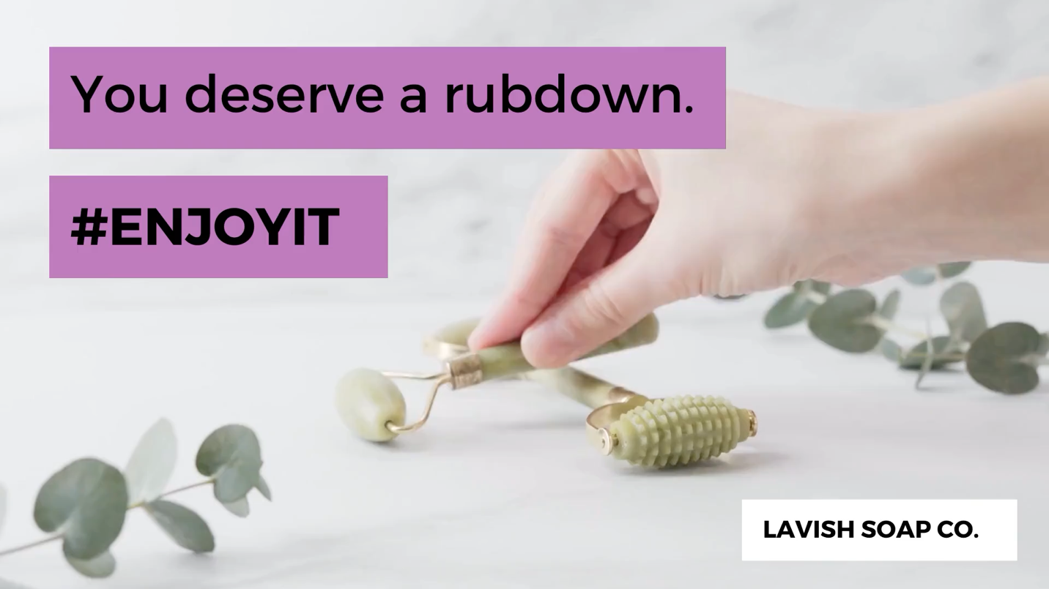We will develop two campaigns to entice our segmented users to try our products. The first will use YouTube to identify the enjoyment and satisfaction our customers will get from them.

The second will appeal to the great value of our products through a first-time purchase of our products through Facebook. There will also be a targeted additional discount in the cart for trying one of our other products.